ASL Dictionary: 5000+ words translated to ASL video and fingerspelling exercises and quizzes. One feature that sets this app apart is the capability to create a favorites list (and favorites quiz) which will allow staff to easily access a list of library specific signs. Available for Apple and Android devices. This cost of this app is $7.99.
ASL Translator: Text-to-Sign Generator. Over 30,000 words translated into Seamless Sign Language Video in real time! Translates up to 50 words at a time and fingerspells any word not in the 30,000 word database. This app features “patented technology that seamlessly connects each signed word to display a smooth video stream, the only software with this unique feature”. Makers of the app ask users to please keep in mind that ASL translation is signed in English word order using a Smart Translation Algorithm. Available for Apple and Android devices. This app is $4.99.
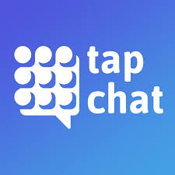 Tap Chat: This is a simple Augmentative and Alternative Communication (AAC) or Picture Communication app. It comes with preloaded categories and boards, but is fully customizable with the capability to upload or choose alternative photos and use familiar voices. Available for Apple and Android devices. This app is free.
Narrator's Voice: Bring text to life with Narrator's Voice! This app has 18 adjustable synthesized voices which speak the words entered into the text box. This app uses a number of languages, as well. Available for Apple and Android devices. This app is free.

