

*Dungeons & Dragons*​  
*Programming for Adults and Teens*​

(When you have little to no experience and an even smaller budget)​

Presented by Catherine (Cat) Roberts, Morristown Branch Manager, Shelby County Public Library

DIY (Difference is You) Conference, September 19, 2025, at the Indiana State Library

Image: Sets of polyhedral dice on felt lined trays with
miniatures for dungeons and dragons tabletop rpg. A red
dice set on a green tray is in the foreground.

Image: Sets of polyhedral dice on felt lined trays with miniatures for dungeons and dragons tabletop rpg. A red dice set on a green tray is in the foreground.

Background:

* Branch Manager & Librarian​
* Velma Wortman Morristown Branch, Shelby County Public Library​
* Working in Libraries for 12+ years​

-~6 years Circulation/Library Assistant​

-~6 years Branch Manager (wearing all the hats)​

-Currently working in a branch with 4 total staff​

-Started with only 2 total staff & annual budget of $6000 for collection, $600for program materials​

-Learned quickly how to improvise and work within a shoestring budget

Dungeons & Dragons? DnD? D&D?

* Over 50 years of gameplay​
* TTRPG = Tabletop Role Playing Game​
* Skills involved:​

  -Basic Math​

  -Critical Thinking​

  -Teamwork​

  -Creative Writing/Storytelling​

  -Problem Solving​

* PopCulture​

  -Television​

  -Movies​

  -Video Games​

  -Podcasts​

  -Webseries

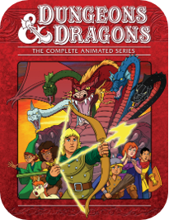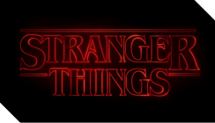 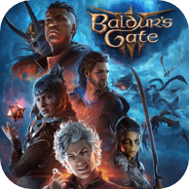  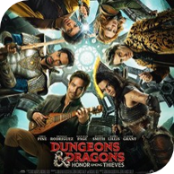

Popular Media representations of Dungeons & Dragons include, but are not limited to: Baldur’s Gate III (Videogame, Larian Studios, 2023), Stranger Things (Television series, Netflix, 2016-present), Dungeons & Dragons: Honor Among Thieves (Feature film, Paramount Pictures, 2023), Dungeons & Dragons (Television series, Marvel Productions and D&D Entertainment, 1983), Tiny Tina’s Wonderlands (Videogame, 2K Games, 2022), and The Legend of Vox Machina (Actual Play webseries adapted to television series, Critical Role and Amazon Prime Video, 2022-present)

No really, what is D&D?

Video Clip from "Real Ones" with Jon Bernthal. ​  
Clip Title: Deb Shows Jon How to Play Dungeons & Dragons. ​  
Clip description: Deborah Ann Woll demonstrated how to play Dungeons & Dragons to Jon Bernthal through imaginative storytelling. ​(Closed captions are available at the link)  
Clip link: [https://www.youtube.com/watch?v=JpVJZrabMQE](https://protect.checkpoint.com/v2/r01/___https://www.youtube.com/watch?v=JpVJZrabMQE___.YzJ1OnN0YXRlb2ZpbmRpYW5hOmM6bzplMTEyY2JiMTgxM2RjYWZhOGM0MTdlYzAyNDhkMmE2NDo3OmRhOWI6ZTdkMGNjNDI4YzhhMDYwYThhNjJkZjQ2MzU5OGZlNDU4ZTA4Yzk2YTVhNjRlMTZhMmExOGE2MmFmOTIxZDVjNjpwOlQ6Tg)

[](https://www.youtube.com/embed/JpVJZrabMQE?feature=oembed)

Deborah Ann Woll Teaches Jon Bernthal Dungeons and Dragons

Make Connections

* Where's the interest?​
* Ask your patrons!​
* It can all start with just ONE person.​
* Call-out events​

-In-person​

-Online

Photo of a group of teens around a table with a librarian, playing Dungeons &
Dragons. The table has books, papers, miniature figurines, maps, and dice on it.​

Photo of a group of teens around a table with a librarian, playing Dungeons & Dragons. The table has books, papers, miniature figurines, maps, and dice on it.​

Photo of a group of kids around a table with librarians, playing Dungeons & Dragons.
The table has books, papers, and dice on it.​

Photo of a group of kids around a table with librarians, playing Dungeons & Dragons. The table has books, papers, and dice on it.​

Library Resources

* Wizards of the Coast​

D&D Afterschool Club Kit​

Dndbeyond.com Educator License (currently unavailable, please contact customer support for Wizards of the Coast for more information)

When it is restored to the website, use this link to submit a request for a D&D Educator Kit: https://dnd-support.wizards.com/hc/en-us​

Submit Request – select D&D Educator Kit, fill out form​

* Local Game/Comic Shops​
* Volunteers? Donations? How-to-Play sessions?​
* Inter-library loan for source books

Screenshot of dndbeyond website, showing character thumbnail images from a
Dungeons & Dragons adventure campaign.​

Screenshot of dndbeyond website, showing character thumbnail images from a Dungeons & Dragons adventure campaign.​

Obstacles & Solutions

* Scheduling​
  + Set a time for programming, keep consistent. Patrons may not always be able to attend, give grace.
* Availability​
  + Be upfront and honest with yourself, patrons, and coworkers about availability. Don't be afraid to cancel or postpone if necessary. Allow your group to still meet even if a session isn't running. Other activities are available related to the game!
* "Satanic Panic"​
  + Promote the positive!
  + Refer back to math skills, critical thinking, teamwork, creative writing/storytelling, problem solving
* Not Enough Players?​
  + Even one player can still make a good story.
* Too Many Players??​
  + Ask your players if they want to help run games; make more than one group to play.​
* Story ideas​
  + What’s your favorite fantasy story? Lead them through it and don’t be afraid to change the story. Otherwise, the internet is a great resource to find pre-made stories.
* Roleplay?
  + Share resources, Let your players know what you expect.

Internet Resources

* Reddit​
* [https://www.dmsguild.com/browse.php?pfrom=0&pto=0](https://protect.checkpoint.com/v2/r01/___http://duhttps/www.dmsguild.com/browse.php?pfrom=0&pto=0___.YzJ1OnN0YXRlb2ZpbmRpYW5hOmM6bzplMTEyY2JiMTgxM2RjYWZhOGM0MTdlYzAyNDhkMmE2NDo3OmRmZDY6N2ZhZjg5NWI0ODBiMDE0MWEzM2ZkOWFkMjE4NzU0YjlkODNlNTlmODNhODJjY2FjZDU3ODkzOWNmODcwNDM4OTpwOlQ6Tg) Dungeon Masters Guild​
* [http://dndbeyond.com](https://protect.checkpoint.com/v2/r01/___http://dndbeyond.com/___.YzJ1OnN0YXRlb2ZpbmRpYW5hOmM6bzplMTEyY2JiMTgxM2RjYWZhOGM0MTdlYzAyNDhkMmE2NDo3OjdiOGE6NTc4NWFlNzQwNDBmNTFkMzE0YjkwOWU4ODdjYzU2Yjg2YWZhZDM4MjkyYjNkM2M1YmFlMjg4OWU3ZTg4YzBkMTpwOlQ6Tg) dndbeyond​
* [http://5e.tools](https://protect.checkpoint.com/v2/r01/___http://5e.tools/___.YzJ1OnN0YXRlb2ZpbmRpYW5hOmM6bzplMTEyY2JiMTgxM2RjYWZhOGM0MTdlYzAyNDhkMmE2NDo3OjE0ODc6NzgyNGY3ZDdjNzgyMTUwZTc1NzVhZTM5NDkzY2M4M2RlZDc3NjI5NDQ5MDA4MWFjZWYyM2Y3Yzc5MTI5ZDVkNTpwOlQ6Tg) 5e.tools ​
* [http://donjon.bin.sh](https://protect.checkpoint.com/v2/r01/___http://donjon.bin.sh/___.YzJ1OnN0YXRlb2ZpbmRpYW5hOmM6bzplMTEyY2JiMTgxM2RjYWZhOGM0MTdlYzAyNDhkMmE2NDo3OjNkNzE6MWI5ZmJkZjE1NTE0NDE3N2RhNTcwNTZjZDA3YjUyNmU1NWFlNDE3ZWRhMDVhMTE0ODI1MDU0OTJmMDhkODRmNzpwOlQ6Tg) Donjon.bin.sh​
* [https://archive.org/search?query=dungeon+magazine](https://protect.checkpoint.com/v2/r01/___https://archive.org/search?query=dungeon+magazine___.YzJ1OnN0YXRlb2ZpbmRpYW5hOmM6bzplMTEyY2JiMTgxM2RjYWZhOGM0MTdlYzAyNDhkMmE2NDo3OjYxMDM6Y2E0NjE1ZmE3Yzc4YTNjMWM0NDRhN2RkYWRhNTYzZDA3MGUxNjQwMjU5M2ZiN2UyYjMzMjM1N2E2YTc0NTdmZDpwOlQ6Tg) Archive of Dungeon Magazine ​
* [https://www.themonstersknow.com/](https://protect.checkpoint.com/v2/r01/___https://www.themonstersknow.com/___.YzJ1OnN0YXRlb2ZpbmRpYW5hOmM6bzplMTEyY2JiMTgxM2RjYWZhOGM0MTdlYzAyNDhkMmE2NDo3OjQ1NmQ6NWFiNmU4MzU4NzQ2MzdiNDgxMzU1NTM3YjQ2MzllY2QwZjg2MDc4ZGVjZTA4MzMwMzI1ZjMzNDAxODJjYjdlYjpwOlQ6Tg) The Monsters Know What They're Doing​
* [https://app.dungeonscrawl.com/](https://protect.checkpoint.com/v2/r01/___https://app.dungeonscrawl.com/___.YzJ1OnN0YXRlb2ZpbmRpYW5hOmM6bzplMTEyY2JiMTgxM2RjYWZhOGM0MTdlYzAyNDhkMmE2NDo3OjE0NmI6MzZlNTYzMmQyM2RjNGViMjkxOWJiZWM1NTkxYTkwYzJjNmVjNmY1ZDU5MDFmOWQ0Mjg2MGU0YjJjNGM3ZmZlNDpwOlQ6Tg) Dungeon Scrawl ​
* Instagram & Facebook reels, TikTok​
* And many, many more!

Helpful Tips

* Don't get stuck in the sources!​
* "It's really more of a guideline than an actual rule"​
* Set Expectations Early​
* Don't sleep on Session Zero​
* If you want the extras, you can easily make them yourself(dice trays, DM screens, dice bags, miniatures, grid maps)​
* Let the algorithm pull you down the rabbit hole

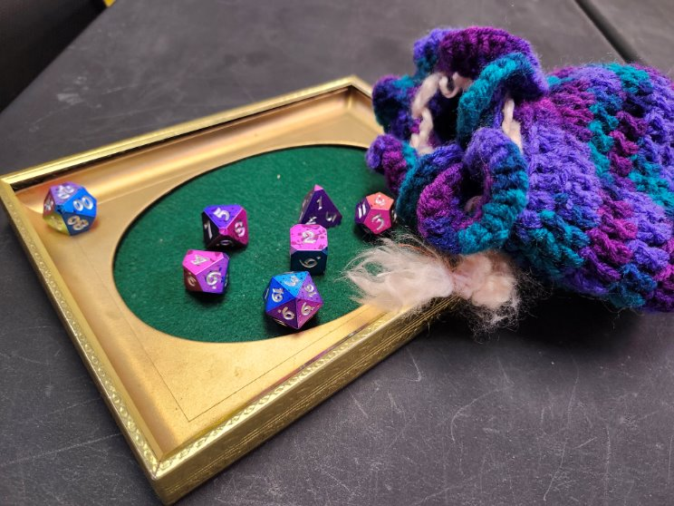

Photo of a crocheted purple and teal dice bag with a polyhedral dice set falling out of it onto a photo frame repurposed with green felt to be a dice tray.

More resources for D&D:​ learn to roleplay, become a dungeon master & more ​(compiled by our branch's resident D&D staffer!)​

* Ginny Di:​  
   [https://www.youtube.com/@GinnyDi/videos](https://protect.checkpoint.com/v2/r01/___https://www.youtube.com/_@GinnyDi/videos___.YzJ1OnN0YXRlb2ZpbmRpYW5hOmM6bzplMTEyY2JiMTgxM2RjYWZhOGM0MTdlYzAyNDhkMmE2NDo3OjU0NTE6NDFlNzYxMDc1MWUxYmFkMjM4ZDA1ODViOTM5Y2U1ZmVlYmFhYzAwNGViYjBkNGIyOGY4ZjhjZmFkMDM1YmY0YTpwOlQ6Tg)​
* Dungeon Dudes:​  
   [https://www.youtube.com/@DungeonDudes/videos](https://protect.checkpoint.com/v2/r01/___https://www.youtube.com/_@DungeonDudes/videos___.YzJ1OnN0YXRlb2ZpbmRpYW5hOmM6bzplMTEyY2JiMTgxM2RjYWZhOGM0MTdlYzAyNDhkMmE2NDo3OjFmZDA6MzQzOWNhOWM4NGEzY2I5NWNmMjhiYzdjYWY0YjEzYTVjNTllMDdlMmFkODFlMDY5OTYxZDU2OWExZDVhODhhMzpwOlQ6Tg)​
* Matthew Colville:​  
   [https://www.youtube.com/@mcolville/playlists](https://protect.checkpoint.com/v2/r01/___https://www.youtube.com/_@mcolville/playlists___.YzJ1OnN0YXRlb2ZpbmRpYW5hOmM6bzplMTEyY2JiMTgxM2RjYWZhOGM0MTdlYzAyNDhkMmE2NDo3OjY0ODg6ZjUyNGE2ZGNkNjUwODMxZGJiNjI1YWNjMTg4ZTk4MjM5YWE5OGZlMTg2MGEzOTJjODhlNWMxOWNhM2JmOTAxNDpwOlQ6Tg)​
* Power Word Spill: ​  
  [https://www.youtube.com/@powerwordspill/videos](https://protect.checkpoint.com/v2/r01/___https://www.youtube.com/_@powerwordspill/videos___.YzJ1OnN0YXRlb2ZpbmRpYW5hOmM6bzplMTEyY2JiMTgxM2RjYWZhOGM0MTdlYzAyNDhkMmE2NDo3OjQzOTA6ZWQ1YjA2MGU1ZjFhMjIxZTZlOGI0OTg4NDNlMzEwOTdkNmM1MGZiNGY0NDlkNjllMzRlYjVkNTYzYjcwNDRiYTpwOlQ6Tg)​
* Adventuring Academy w/ Brennan Lee Mulligan:​  
   [https://www.youtube.com/watch?v=pURrup121Xk&list=PL9N3uh1EptF9vLBvG_2wClBASoPUWHF-X](https://protect.checkpoint.com/v2/r01/___https://www.youtube.com/watch?v=pURrup121Xk&list=PL9N3uh1EptF9vLBvG_2wClBASoPUWHF-X___.YzJ1OnN0YXRlb2ZpbmRpYW5hOmM6bzplMTEyY2JiMTgxM2RjYWZhOGM0MTdlYzAyNDhkMmE2NDo3OjMyZGY6Y2RlMjBkMTlkYjkzOGEzN2U4ZDc0NzcwZDRkMmRhYmE5YzhlNDU2YmZhNDIxNGFjOTJjZTY4ZjFhNjE0MjgzMTpwOlQ6Tg)

Photo of a group of teens around a table with a librarian, playing Dungeons &
Dragons. The table has books, papers, miniature figurines, maps, and dice on it.​

Photo of a group of teens around a table with a librarian, playing Dungeons & Dragons. The table has books, papers, miniature figurines, maps, and dice on it.​

Supplies*

* Dice​
* Maps​
* Character Sheets​
* Pencils/Paper​
* Dungeon Master Screen​
* Dice Trays / Towers / Storage Bags​
* Miniatures​
* VTT (Virtual Table Top)​
* ​
* ​

*None of these are fully necessary to play DnD, and if they are, there are free options available.

image shows a virtual tabletop setup for
Dungeons & Dragons. It has a television laying flat with a
map displayed on it, and miniature figurines representing
player's characters are arranged on top of it.

image shows a virtual tabletop setup for Dungeons & Dragons. It has a television laying flat with a map displayed on it, and miniature figurines representing player's characters are arranged on top of it.

Let’s Play! Questions?

Cat Roberts, Branch Manager

Velma Wortman Morristown Branch of the Shelby County Public Library

[croberts@sscpl.lib.in.us](mailto:croberts@sscpl.lib.in.us)

CatTheLibrarianDM on dndbeyond

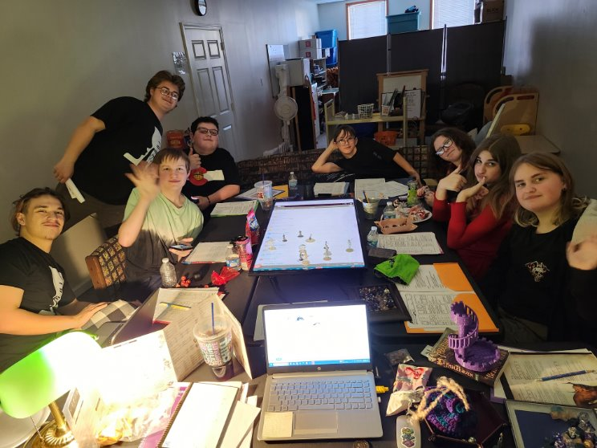

Photo of a group of teens around a table with a librarian, playing Dungeons & Dragons. The table has books, papers, miniature figurines, a virtual map on a television screen, and dice on it.​